**Развитие профессиональной компетентности учителя по формированию функциональной грамотности учащихся**

**Функциональная грамотность**

* **Читательская грамотность**
* Глобальные компетенции
* Креативное мышление
* Финансовая грамотность
* Естественнонаучная грамотность
* Математическая грамотность

**Определение PISA:**

**Читательская грамотность** – это способность человека понимать и использоватьписьменные тексты, размышлять о них и заниматься чтением для того, чтобы достигать своих целей, расширять свои знания и возможности, участвовать в социальной жизни.

**Понятие «текст»**

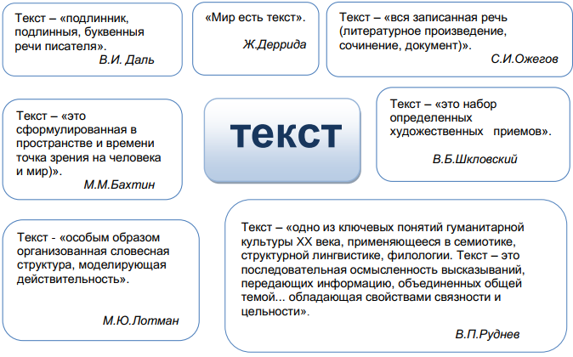

**Сплошные и несплошные тексты**

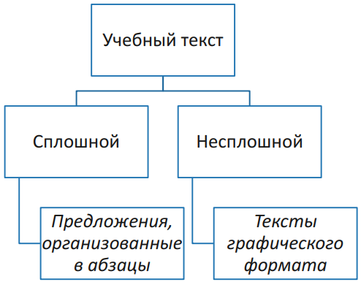

**Сплошные:**

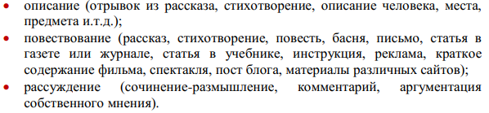

**Несплошные:**

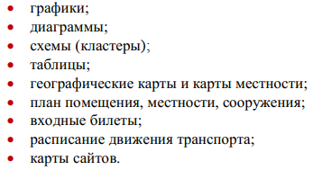

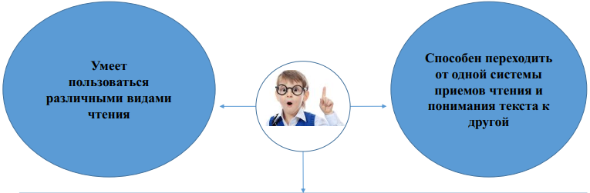

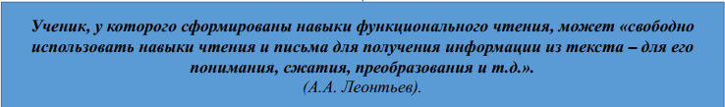

**Фазы чтения**

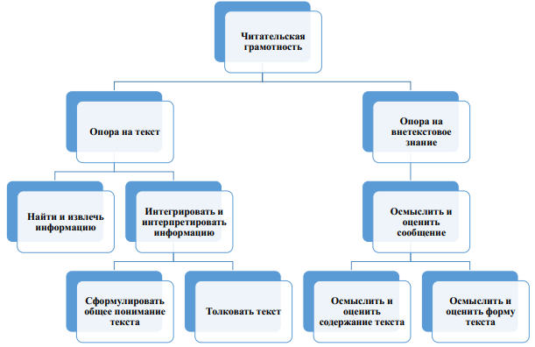

**Уровни понимания текста**

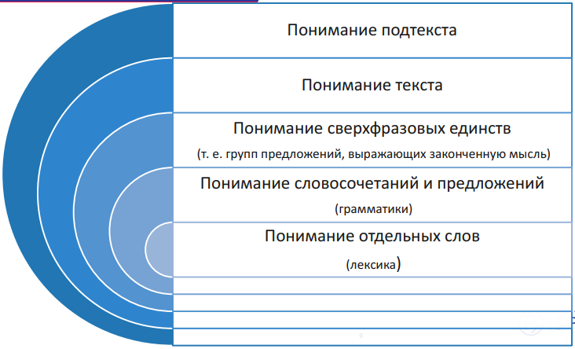

**Приёмы определения уровня понимания текста**

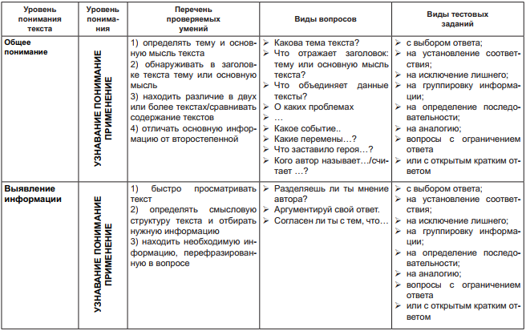

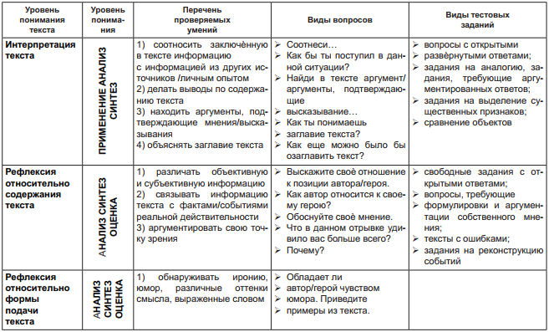

**Основная причина невысоких результатов выпускников основной школы:** недостаточная сформированность способности использовать имеющиеся предметные знания и умения при решении задач, приближенных к реальным ситуациям.

**Продуктивные задания** - это творческое воспроизведение знаний. Каждый ученик должен сам и по-своему выразить полученное на уроке знание и представить на суд учителю и одноклассникам собственный продукт. Отсюда и название.

**Как узнать продуктивное задание?**

1. это деятельностное задание;
2. оно моделирует практическую, жизненную ситуацию;
3. оно строится на актуальном для учащихся материале.

**Преобразование репродуктивных заданий в продуктивные**

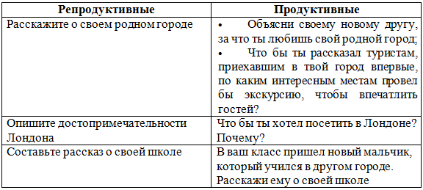

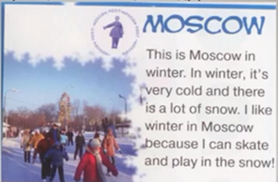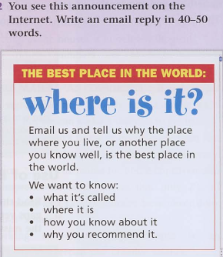



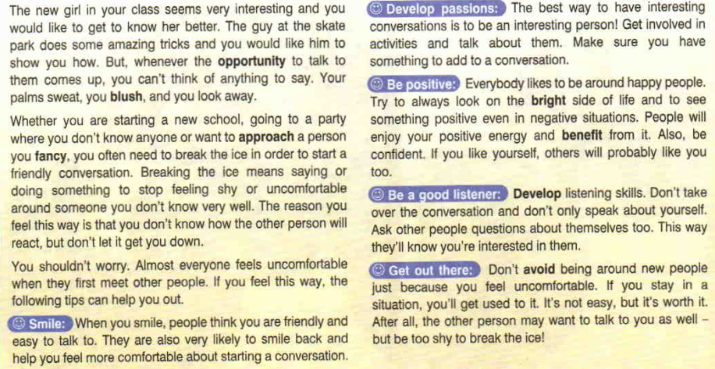

**Общее понимание текста**

1. What is the author's purpose for writing the passage? (To entertain, persuade, inform, advise, narrate, describe).
2. What is the topic of the text? (What is the text about?)
3. What is the main idea of the text? (The most important thought about the topic)
4. What does “Break the ice” mean?
5. Why do people feel uncomfortable when they first meet other people?
6. List the tips on how to stop being shy and uncomfortable around the people you don’t know well.
7. What does your smile say about you?
8. What is the best way to have interesting conversations?
9. Why is it important to be positive?
10. In what way can people know you’re interested in them?
11. Mark the sentences 1-7, T (True), F (False) or DS (Doesn’t Say):
12. Breaking the ice means saying or doing something to start feeling relaxed with a new person.
13. People feel uncomfortable when meeting someone new because they cannot predict their reactions.
14. Some people don’t have any passions.
15. When you meet someone for the first time, it’s better to look serious.
16. Confident people don’t postpone things.
17. When you start a conversation, talk a lot about yourself.
18. If you feel uncomfortable with new people, avoid being around them.

**Выявление информации**

1. Explain what the phrases mean:
2. “Your palms sweat, you blush …” (in the 1st paragraph)
3. “To approach a person you fancy” (in the 2nd paragraph)
4. “To look on the bright side” (in the 6th paragraph)
5. “People will enjoy your positive energy and benefit from it” (in the 6th paragraph)
6. Paraphrase (say or write in your own words without changing the meaning) the paragraphs:
7. Smile;
8. Develop passions;
9. Be positive;
10. Be a good listener;
11. Get out there.
12. Fill in Cause and Effect chart

Cause and Effect

|  |  |
| --- | --- |
| **When you first meet other people** | |
| **If you** | **People’s reaction** |
| smile |  |
| are an interesting person |  |
| are positive |  |
| are a good listener |  |

1. Rank the following tips in order of importance from 1 to 5 where 1 is the most important to you and 5 is the least important to you. Give your arguments.

Ranking

|  |  |
| --- | --- |
| Tips | 1-5 |
| Smile |  |
| Develop passions |  |
| Be positive |  |
| Be a good listener |  |
| Get out there |  |

1. Retell the text in your words.
2. Summarize the text in your words (reduce the text to its main idea and necessary information).

**Интерпретация текста**

1. Describe a situation when you had a chance to get to know someone better but you were not able to think of anything to say.
2. Imagine you are at the International Youth Camp.
3. Make a list of questions (7-8) to ask your new English-speaking friend to show you are interested in him/her?
4. Tell your new friends about your hobby.
5. Advise your new friend how to overcome his/her shyness and start talking when he/she first meets someone.
6. What do you understand by the phrase “If you like yourself, others will probably like you too”?
7. Is the title of the text appropriate? Why/why not?
8. Why did the author choose this title?
9. Explain how the passage supports the author’s purpose.
10. What other title can you suggest for the text?
11. Convert the text information to a mind map.

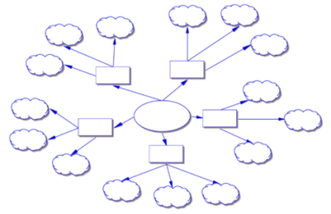

**Рефлексия относительно содержания текста и формы подачи текста**

1. How can you put into practice the information of this passage?
2. Did you find the author’s style persuasive? Why or why not?
3. Do you agree with what you read? Why or why not?

**Видео**

[**https://www.youtube.com/watch?v=Ph19Mp5h_Jk**](https://www.youtube.com/watch?v=Ph19Mp5h_Jk)

**One Call Away** (Charlie Puth)

[**https://www.youtube.com/watch?v=BxuY9FET9Y4**](https://www.youtube.com/watch?v=BxuY9FET9Y4)

I'm only one call away  
I'll be there to save the day  
Superman got nothing on me  
I'm only one call away  
  
Call me, baby, if you need a friend  
I just wanna give you love  
C'mon, c'mon, c'mon  
Reaching out to you, so take a chance  
  
No matter where you go  
You know you're not alone  
  
I'm only one call away  
I'll be there to save the day  
Superman got nothing on me  
I'm only one call away  
  
Come along with me and don't be scared  
I just wanna set you free  
C'mon, c'mon, c'mon  
You and me can make it anywhere  
For now, we can stay here for a while  
Cause you know, I just wanna see you smile  
  
No matter where you go  
You know you're not alone  
  
I'm only one call away  
I'll be there to save the day  
Superman got nothing on me  
I'm only one call away  
  
And when you're weak I'll be strong  
I'm gonna keep holding on  
Now don't you worry, it won't be long  
Darling, and when you feel like hope is gone  
Just run into my arms  
  
I'm only one call away  
I'll be there to save the day  
Superman got nothing on me  
I'm only one, I'm only one call away  
I'll be there to save the day  
Superman got nothing on me  
I'm only one call away  
  
I'm only one call away